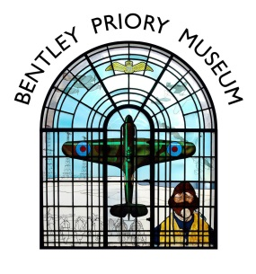
Office Use:
Date Form Received:
Signed:

Date Payment/s Received:
£50 deposit
50% lunch deposit
Signed:

Bentley Priory Museum Group Booking Form
Group Details
Group Name:
Organiser’s Name: Telephone Number:
Address: Email:
Visit Details
Date of Visit: Group Size:
Time of Arrival: Time of Departure:
Coach Parking: Yes/No (please delete as appropriate)
Guided Tour
Would you like a Guided Tour (no charge)? Yes/No (please delete as appropriate)
Tour Start Time:
We offer 2 tour options, please select one:
Bentley Priory and the Battle of Britain ☐
Bentley Priory: The Evolution of an Historic House ☐
Refreshments (available at additional cost)
Tea/Coffee on Arrival: Yes/No Tea/Coffee on Departure: Yes/No
Lunch: Yes/No Afternoon Tea: Yes/No
Lunch/Afternoon Tea must be pre-ordered, with final numbers and menu choices confirmed at least 2 weeks before the visit.
Payment
A £50 non-refundable deposit is required by cheque 1 month before your visit. This will be deducted from the final amount payable on the day for your admission.
Afternoon Tea: A 50% non-refundable deposit is required by cheque 1 month before your visit.
Cheques payable to Bentley Priory Museum
Please return the Group Booking Form to groupbookings@bentleypriorymuseum.org.uk or Bentley Priory Museum, Mansion House Drive, Stanmore, HA7 3FB

