Bentley Priory Museum Group Visit Menu

Please Note: Pre-ordering is essential

Please notify us of all pre-orders a minimum of 2 weeks before the visit at groupbookings@bentleypriorymuseum.org.uk. 50% deposit for refreshments/meals is payable at that time

Sandwiches - £4.50 per person
Available as individual preorders or as buffet selection for whole group

Tuna Mayonnaise & Sweetcorn
Egg Mayonnaise & Cress
Cheese & Pickle
Brie & Cranberry
Hummus & Roasted peppers

Soup & Roll - £4.40 per person
Cream of tomato
Vegetable

Soup & Sandwich Combo - £8.40 per person

Jacket Potatoes - £5.40 per person
Choice of Fillings:

Tuna Mayonnaise
Baked Beans
Cheese
Cheese & Baked Beans (50p extra)

Tea/Coffee - £1.80 per person

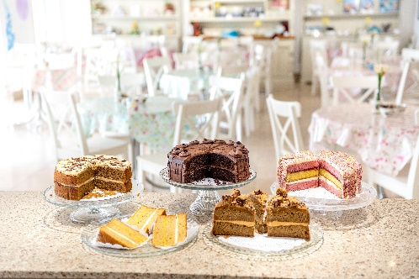
Cream Tea - £6.00 per person
Fruit scone with strawberry jam & clotted cream

Sliced frosted Cakes - £3.00
Chocolate Shortbread @ £1.60
Packet of Biscuits - £1

Options can be pre-ordered individually or the group leader can choose 1 option to be served to everybody.

