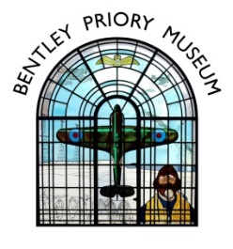

Bentley Priory Museum Afternoon Tea Menu
Served on beautiful vintage china to your table
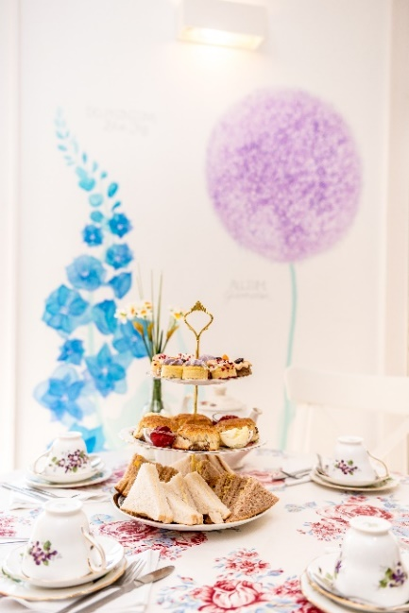
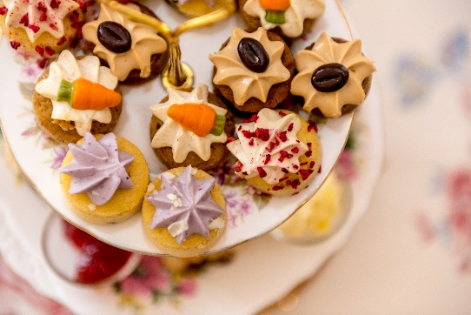
Full Afternoon Tea
£24.00 per person
Minimum quantity 4 people

Sandwiches

Smoked salmon
Free Range Egg Mayonnaise
Cucumber
Vintage Farmhouse Cheese & tomato

Handmade fruit scone with strawberry jam & clotted cream

Selection of small patisseries

Unlimited Tea or Coffee

Cream Tea £7 per person
Fruit scone with strawberry jam & clotted cream
Pot of Tea or Coffee
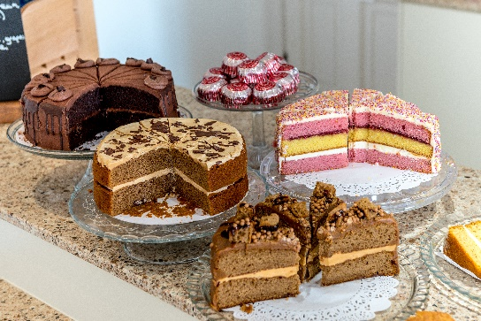
Tea/Coffee & Cake £5.50 per person
Choice from selection of sliced frosted cakes
Hot drink

Tea/Coffee & Biscuits £3.30 per person
Hot drink & packet of luxury biscuits

Tea/coffee & pastries £4.70 per person
Hot drink & a selection of small freshly baked Danish pastries

GROUPS: Please select 1 option for the full group. Please note that payment is required as a lump sum, not to be paid individually. Final choices and exact numbers to be confirmed a minimum of 2 weeks in advance of your visit. 50% non refundable deposit is due at this time

Please send your choices and notification of any food allergies/intolerances to groupbookings@bentleypriorymuseum.org.uk.

